**ALGORITMA WARSHALL**

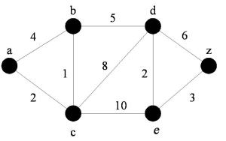Dari Titik A Menuju Titik  Z ada berapa cara :

(A – B – D – Z) —>15

(A – C – E – Z) —>15

(A – B – C – D – Z) —>19

(A – B – C – E – Z) —>18

(A – C – D – Z) —>16

(A – C – D – E – Z) —>15

**ALGORITMA DIJKSTRA**



A + C + B + D + E + Z =

2 + 1 + 5 + 2 + 3 = **13**